Key Components:

1. **Dependent Variable**:  
   Severity (0-100 scale, where 100 = most severe)
2. **Independent Variables**:
   * Speed_Limit (km/h)
   * Road_Condition (Dry/Wet/Icy)
   * Weather (Clear/Rain/Fog/Snow)
   * Light_Condition (Daylight/Dusk/Dark)
   * Vehicle_Age (years)

Example Prediction:

**Hypothetical Scenario**:

* Speed Limit: 80 km/h
* Road Condition: Icy
* Weather: Rain
* Light Condition: Dark
* Vehicle Age: 5 years

**Predicted Severity**: 136.7/100

Benefits for Underdeveloped Countries:

1. **Infrastructure Prioritization**  
   Identify high-impact risk factors (e.g., icy roads + darkness) to prioritize road improvements.
2. **Preventive Policy Design**  
   Implement speed restrictions in high-risk zones based on weather/light conditions.
3. **Emergency Resource Allocation**  
   Predict severity hotspots to strategically position emergency services.
4. **Public Awareness Campaigns**  
   Target driver education on critical risk combinations (e.g., "Reduce speed by 40% on wet nights").
5. **Low-Cost Intervention Planning**  
   Focus on high-impact variables requiring minimal investment (e.g., reflective signage in dark zones).

Model Outputs:

1. **Feature Importance Diagram**:

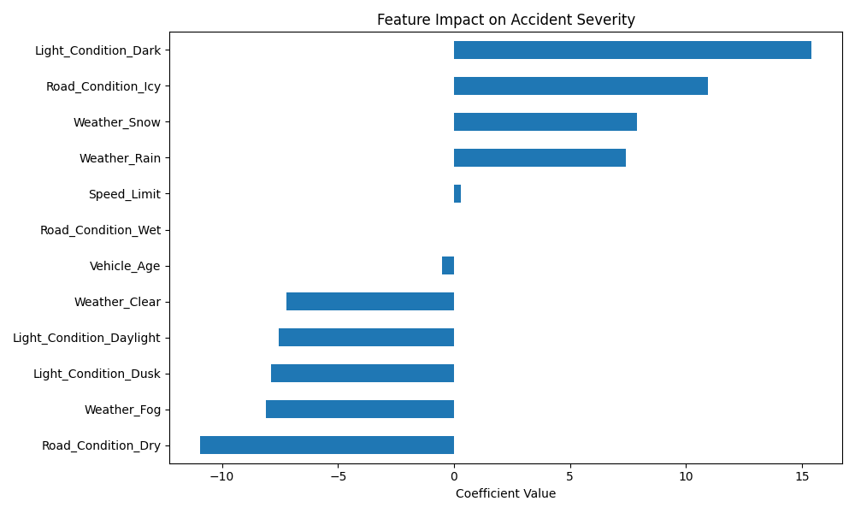  
*Visual showing how each factor influences severity predictions*

1. **Prediction Output**:

Model RMSE: 26.42

Predicted Severity: 136.7/100

1. **Saved Model File**:  
   accident_severity_model.pkl (reusable for new predictions)

This model provides actionable insights for resource-constrained regions by identifying critical risk factors that maximize prevention impact per dollar spent. Combining predictions with local infrastructure data enables evidence-based safety interventions.